DBS Coding Assignment – (shopping cart – microservices + Spring CLOUD Stream)

Author: Sudhan Balaji Sridharan
Date: 19/05/2020
Contents

Problem Statement: 3
Technologies Used: 4
Project Briefing: 4
Detailed Explanation on the Project: 5
Steps to start RabbitMQ & Management Console: 7
Unit Testing: 9
Screenshots: 10
shopping-cart server (Start): 10
Eureka Instance with two services registered: 11
publisher-service Auto-Configure to RabbitMQ Channel (Output Binding): 11
subscriber-service Auto create DB & Input Binding to RabbitMQ Channel & Queue: 12
Shopping Cart Screens (Products & Carts Pages) 13
MySQL Database (Database and Table creation & Table updates by subscriber service) 14
RabbitMQ Management Console (Channel, Queue & Binding): 15

Problem Statement:

- Imagine you are working on a shopping Cart component, when user choose a product, it will
be published to a message queue.
- You are developing a micro service component which receives message from message queue,
save it into database. You can use embedded database/jms for illustration purpose.
The code should:
1. should have good test coverage.
2. the app should not lose message if the database connections go down.
3. The app should be able to auto create table if the table doesn’t exist in database.
4. Self-healing from database issue without human intervention.
5. Good fault tolerate.

Technologies Used:
- Java 11
- SpringBoot
- Microservice Architecture
- RabbitMQ
- Spring Cloud Stream for Rabbit MQ
- JPA
- OpenFeign client
- Netflix-Eureka
- MY-SQL
- Maven
- GitHub
- JUnit
- STS 4 IDE

Project Briefing:

- Created 2 microservices & Netflix-Eureka server:
  - shoppingcart-service Eureka Server. Registered the below services with the shoppingcart-service
  - publisher-service Publishes the message into RabbitMQ upon choosing any product.
  - subscriber-service Subscribes the message from RabbitMQ and updates the DB

- Installed RabbitMQ Steps to start RabbitMQ & Management Console:
- Auto created database (productdb) and table (dbs_products) using SpringBoot JPA + Hibernate Dialect
- Completed Junit testcases for both the microservices and also for the RabbitMQ binding. Tested publisher service with send and receive message
- Attached screen-prints at the end of the document. Refer Screenshots:

Detailed Explanation on the Project:

dbs-shoppingcart-server
- Eureka Server. Running on port: 5555
- Registered the publisher & subscriber services with the eureka server
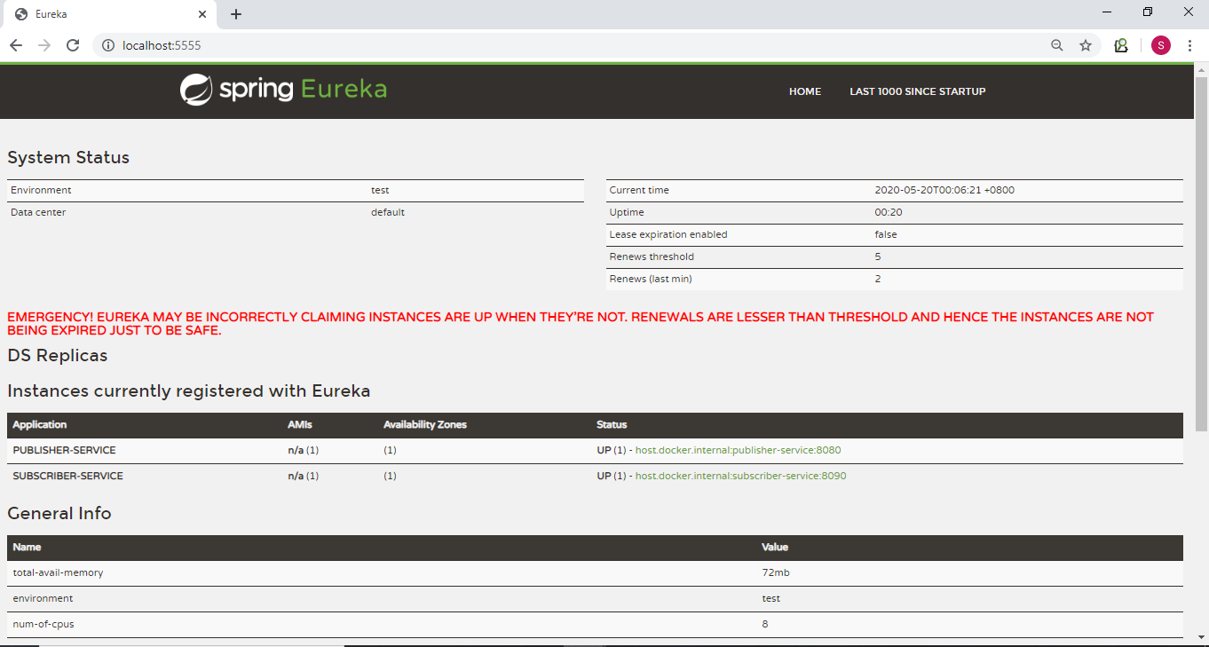

dbs-publisher-service
- Publisher Service. Running on port: 8080
- The publisher service auto-configures to the RabbitMQ binding destination channel using Spring Cloud Stream (Output Binding)
- The publisher service exposes the REST API for the shopping cart application which will fetch the list of products for the UI (JSP).
- Used stub repo for creation of the products
- Upon choosing a product, the RabbitMQ (Output Binding) will send the product selected as a JSON object to the appropriate channel (@Autowired PublisherBinding)
- Completed Junit testcases for message testing and successful. Refer Screenshots:

dbs-subscriber-service
- Subscriber Service: Running on port: 8090
- The subscriber service auto-configures to the RabbitMQ binding destination channel using Spring Cloud Stream (Input Binding)
- Uses Feign Client to communicate with the publisher service & for fallback mechanism
- The subscriber service (RabbitListener service) subscribes the products from the RabbitMQ queue and updates in the DB
- Completed Junit testcases for the Feign client and successful. Refer Screenshots:

Steps to start RabbitMQ & Management Console:

- Start RabbitMQ server rabbitmq-server start
- Enable management plugin rabbitmq-plugins.bat enable rabbitmq_management
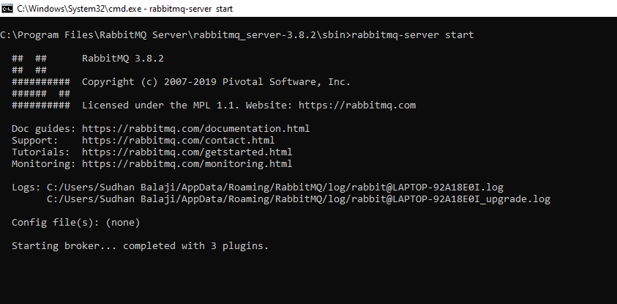
- Start RabbitMQ as a docker (Optional) – Can dockerize RabbitMQ and use docker image of the RabbitMQ if needed
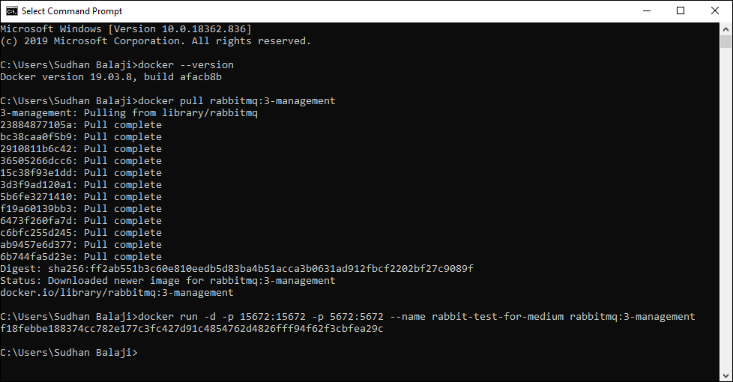
- Login to RabbitMQ console with credentials (guest/guest)
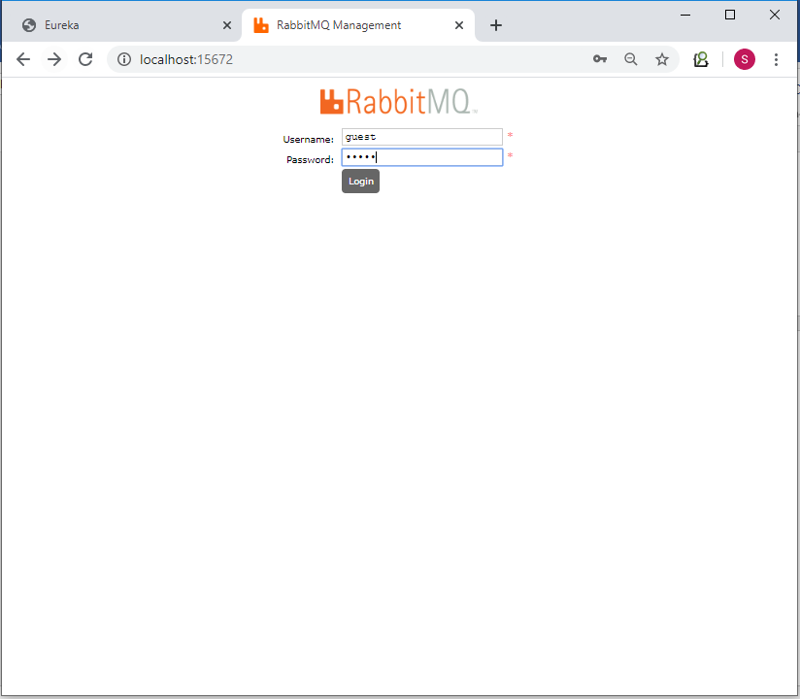

Unit Testing:

Publisher Service:
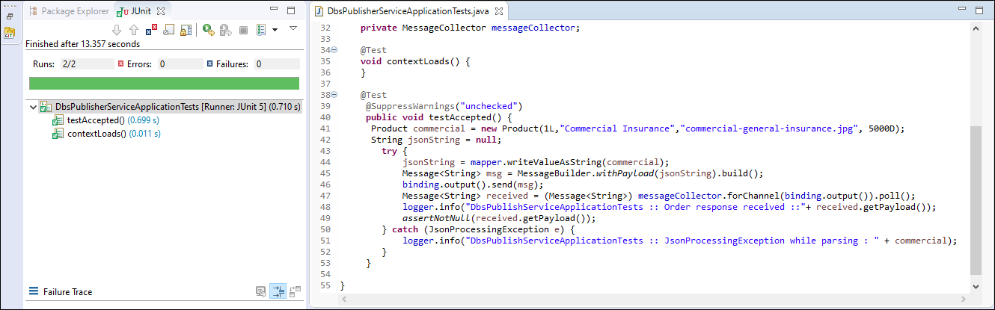

Subscriber Service:
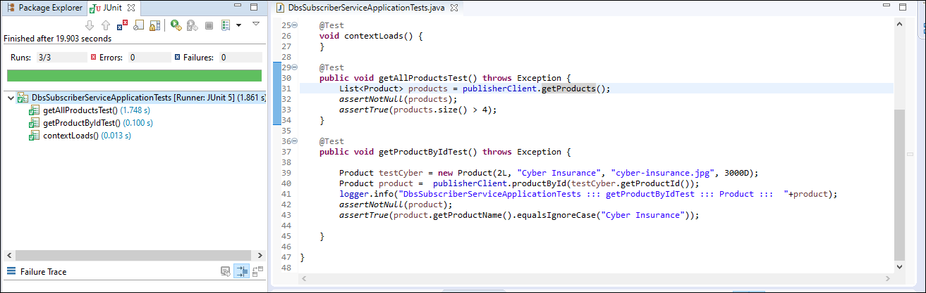

Screenshots:

shopping-cart server (Start):

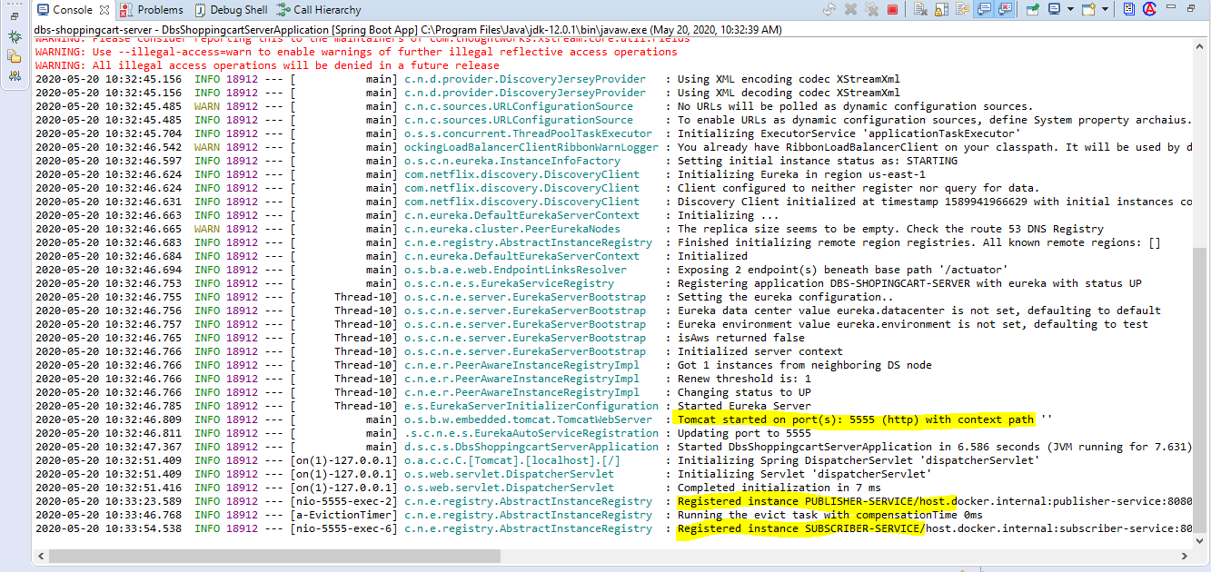

Eureka Instance with two services registered:

publisher-service Auto-Configure to RabbitMQ Channel (Output Binding):

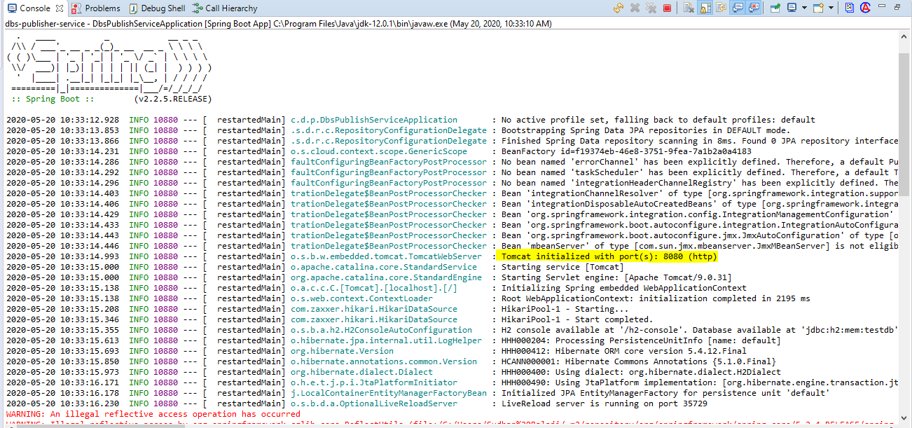

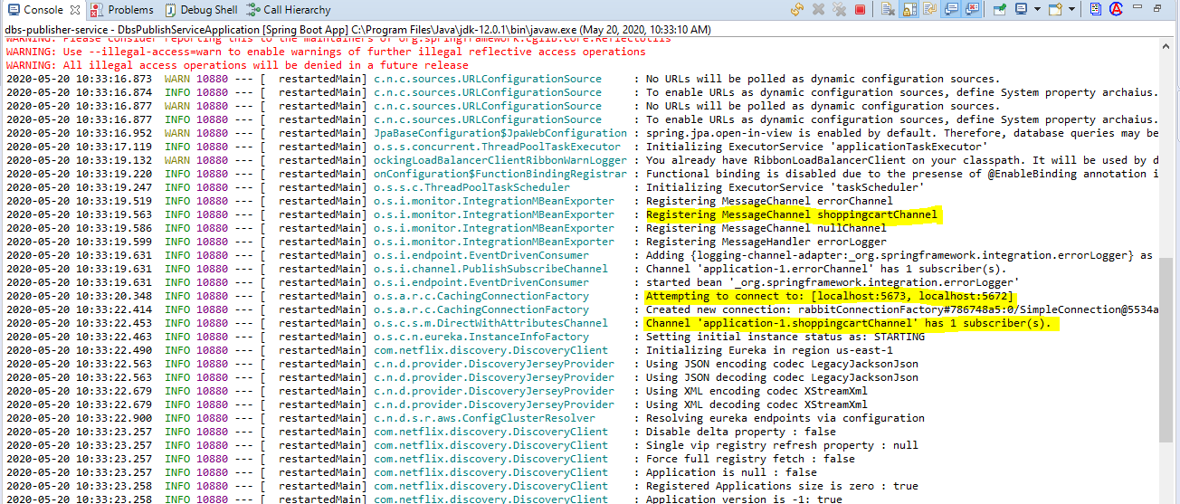

subscriber-service Auto create DB & Input Binding to RabbitMQ Channel & Queue:

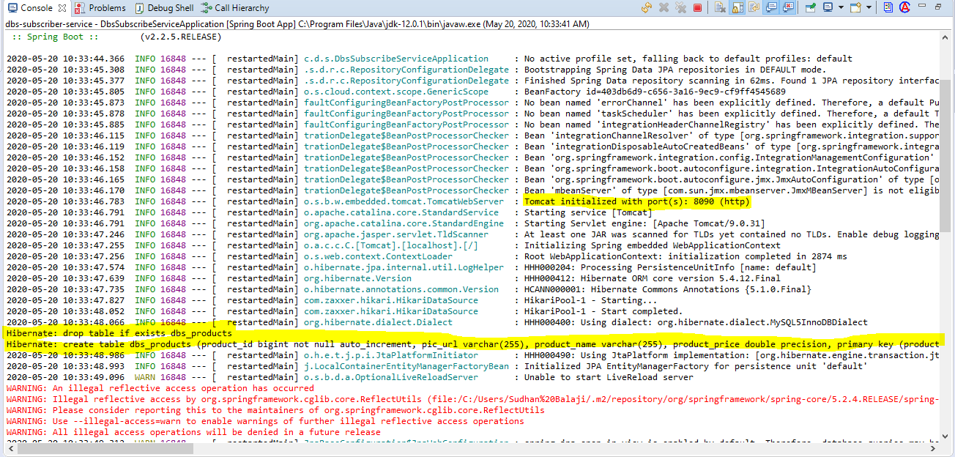

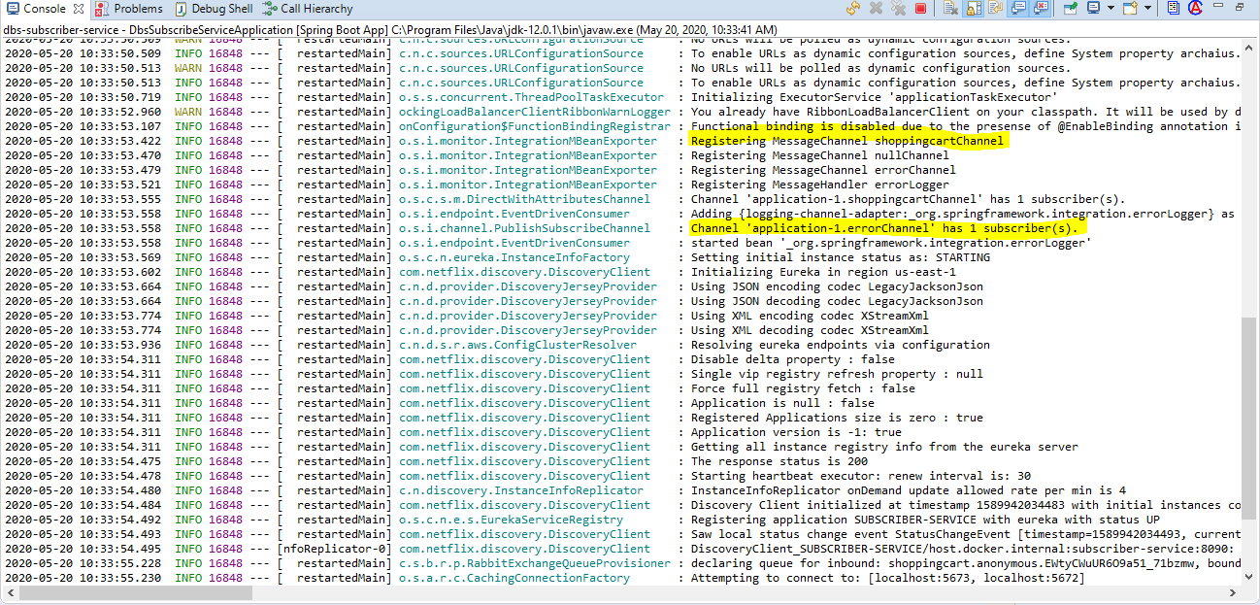

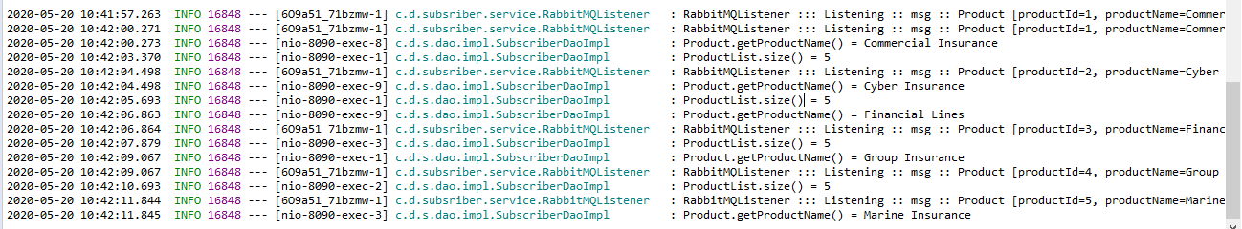

Shopping Cart Screens (Products & Carts Pages)

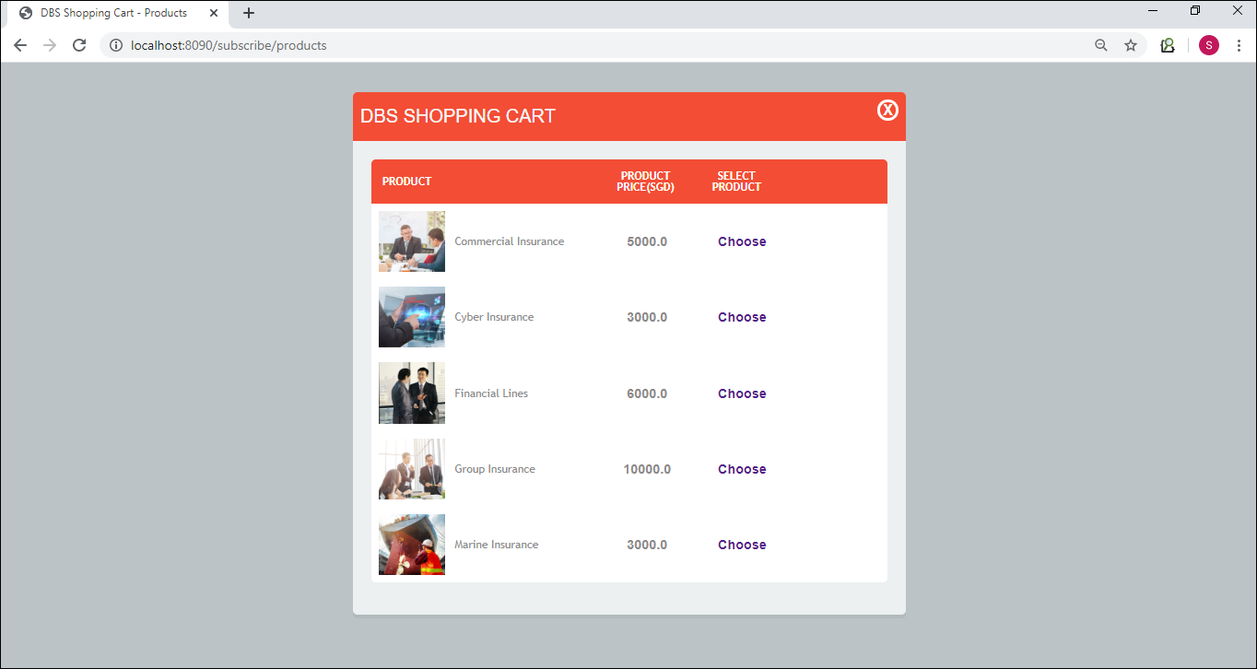

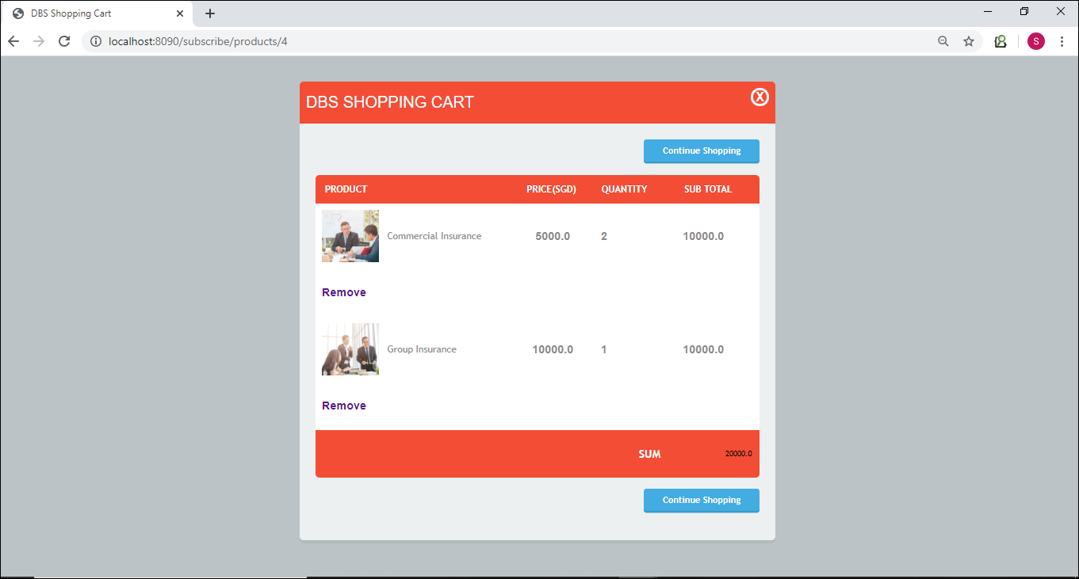

MySQL Database (Database and Table creation & Table updates by subscriber service)

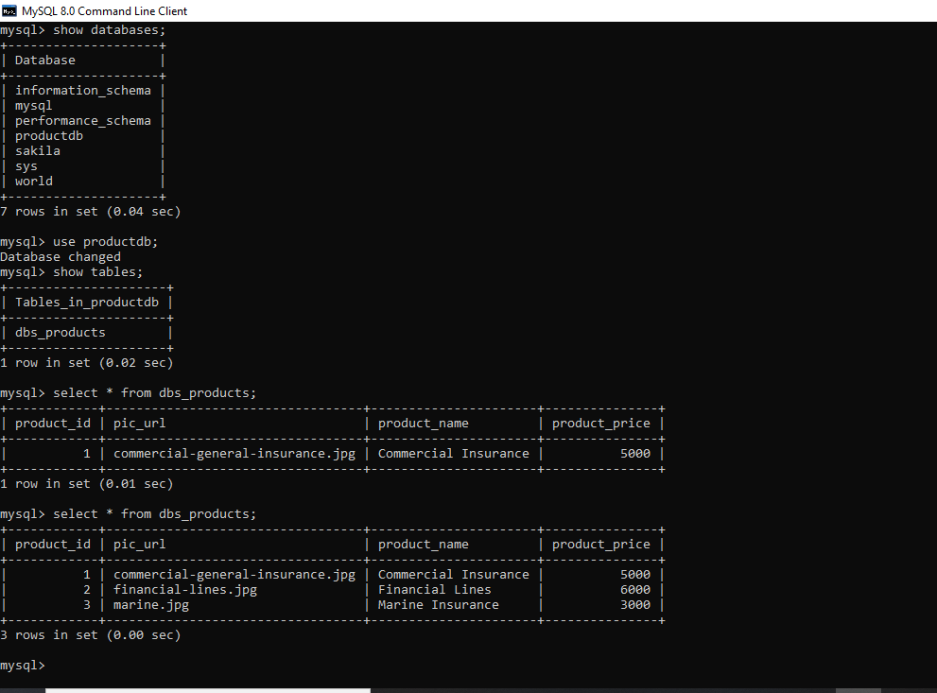

RabbitMQ Management Console (Channel, Queue & Binding):

